CAPSTONE PROJECT PROPOSAL FALL 2025


Real-Time Intrusion and Non-intrusion detection using YOLOv8 and ROI based analysis
Submitted by
MD Rakibul Hassan
ID: 0822220105101024

Md. Tahsin Azad Shaikat
ID: 0822220105101020
Nishat Tasnim
ID: 0822220205101039

Supervised by
Arifur Rahaman
Assistant Professor, Dept. of CSE, BAIUST

in partial fulfillment of the requirements for the degree of
Bachelor of Science in Computer Science and Engineering

DEPARTMENT OF COMPUTER SCIENCE AND ENGINEERING
BANGLADESH ARMY INTERNATIONAL UNIVERSITY OF SCIENCE AND TECHNOLOGY (BAIUST)

DECLARATION
We hereby declare that the work presented in this Capstone Project Proposal is the result of our own investigation and efforts, conducted under the guidance and supervision of Arifur Rahaman, Assistant Professor, Department of Computer Science and Engineering, Army International University of Science and Technology, Cumilla, Bangladesh. We confirm that no part of this proposal has been submitted, nor is being submitted, for the award of any other degree or diploma at any institution.

Countersigned  ------------------------------  (Arifur Rahaman)  Supervisor | Signature  ------------------------  MD Rakibul Hassan  ID: 0822220105101024  ------------------------  Md. Tahsin Azad Shaikat  ID: 0822220105101020  ------------------------  Nishat Tasnim  ID: 0822220205101039

APPROVAL
The Capstone Project titled “Real-Time Intrusion and Non-intrusion detection using YOLOv8 and ROI based analysis”, submitted by MD Rakibul Hassan (0822220105101024), Md. Tahsin Azad Shaikat (0822220105101020), and Nishat Tasnim (0822220205101039) to the Department of Computer Science and Engineering, Bangladesh Army International University of Science and Technology, has been reviewed and approved as satisfactory for partial fulfillment of the requirements for the degree of Bachelor of Science in Computer Science and Engineering.

Board of Examiners

----------------------------------------  Arifur Rahaman  Assistant Professor  Department of Computer Science and Engineering, BAIUST | Supervisor
----------------------------------------  Hasan Abdullah  Assistant Professor  Department of Computer Science and Engineering, BAIUST | Examiner 1
----------------------------------------  Md. Imran Hossain Emu  Lecturer  Department of Computer Science and Engineering, BAIUST | Examiner 2
----------------------------------------  Khandakar Md. Shafin  Lecturer  Department of Computer Science and Engineering, BAIUST | Examiner 3
Table of Contents
1. Introduction 1
2. Project/Research Motivation 1
3. Problem Statement 1
4. Project/Research Objectives 2
5. Related Work/ Literature Review 2
6. Research Questions 4
7. Methodology / Design Approach 5
7.1 Research / Model / Experimental Design 5
8. Project Timeline (Gantt Chart) 9
9. Modern Tools & Technologies 10
10. Ethical Issues 11
10.1 Important Ethical Issues 11
10.2 Demonstration of Ethical Awareness 12
10.3 Commitment of Responsible Research Practices 12
11. Budget Estimation 13
12. Conclusion 13
References 14
Plagiarism & AI-Detect Report: 18
AI-Detect Report: 18
Plagiarism Checking Report: 19

List of Tables
Table 1: Evaluation 7
Table 2: System Integration 8
Table 3: Alert Decision Logic 9
Table 4: Project Timeline (Gantt Chart) 9
Table 5: Modern Tools & Technology 10
Table 6: Budget Estimation 13

List of Figures
Fig 1: System Architecture 5
Fig 2: Data Collection and Preprocessing 6
Fig 3: High Level Design(HLD) 7
Fig 4: Project Timeline(Gantt Chart) 10

1. Introduction
Retail theft and unauthorized access are persistent issues that businesses globally must deal with all the time. They cost businesses significant financial burdens and make it hard for them to run their operations. While modern computer vision has made it possible for automated surveillance, existing systems struggle under low-light conditions and often rely on binary alerts that produce high false positive rates. This research proposes a hybrid computer vision framework that operates in real time to actively detect unauthorized intrusions and suspicious behaviour in homes and retail shops. Notably, when paired with temporal feature analysis, YOLO based object detectors have proven to be highly accurate in real time detection while maintaining computational efficiency.
Moreover, most modern surveillance techniques use binary alarm systems or frame-level detection, which leads to more false positive rates and decreased interpretability. The combination of behavior scoring, systems, trigger based pose-estimation, and temporal action identification. The following algorithms can find out the difference between regular consumer behavior and dangerous conduct by weighting different behavioral cues. This delivers useful information and cuts down on false alarms.
Another important issue is that many existing systems do not properly use Region of Interest (ROI). Without ROI, the system cannot focus on specific important areas, such as restricted zones or entry points. Because of this, it may detect unnecessary activities and increase errors. Adding ROI-based area restriction can help the system focus only on important regions and improve overall accuracy.

2. Project/Research Motivation
Driving Force :
The acceptance of intelligent surveillance systems is still limited in the real world environment.
Motivations :
- Annually, unauthorized access causes retail losses which is harmful for both employee safety and business success.
- Well current motion-detection systems often trigger false alarms due to non-threatening activities.
- Various deep learning models are resource-intensive and not compatible with lightweight edge devices particularly in environments with dynamic background and varying lighting conditions.
- Intrusion detection systems do not give priority to important zones over public regions, which makes it hard to focus on high-risk locations.

3. Problem Statement
Current Situation :
Today’s surveillance systems are restricted because they depend on manual monitoring and fragmented automated solutions that focus only on daytime behavior or night time intrusion. Current alerts use binary classification that are hard to understand and often misclassify benign shopping behaviors as threats, which makes people tired of getting notifications.
Specific Issues :
- Current automated systems sometimes fail to identify differences between real intrusions and normal activities, leading to false alarms and unnecessary responses.
- Standard intrusion detection algorithms do not distinguish between normal public areas and highly sensitive restricted zones, such as cash registers or private entryways; they consider the entire video frame the same.
- Modern deep learning and continuous full-body posture estimation models need a lot of computing power, which makes them unsuitable for real-time use on low-cost, resource-limited devices like ordinary home CCTV systems or Raspberry Pi.
- Existing daytime-optimized models don’t work well at night, when there isn’t sufficient illumination, and they also set off false alarms because of noise in the environment.
- Traditional CCTV systems are primarily reactive, relying on time-consuming manual monitoring or post -incident analysis, which makes it hard to respond quickly to important security incidents.
Solution Statement :
The proposed computer vision system integrates real-time person detection (YOLOv8), Region of Interest (ROI) attention mapping, and CNN-LSTM temporal modeling to identify unauthorized instruction and suspicious behaviour preemptively. The provided system will send security alerts that are accurate and aware of where they are, and it cuts down on false alarms.

4. Project/Research Objectives
Primary Objective :
To develop and evaluate a real-time computer vision system that can detect possible home intrusion and suspicious activities in retail environments using object detection and motion analysis techniques.
Secondary Objectives :
- To use YOLOv8 for fast and accurate person detection so that human movement can be tracked across video frames.
- To define a restricted zone or ROI so the system can separate normal public movement from movement inside sensitive areas.
- Applying a decision-making module that combines detection confidence with the help of simple rules that reduce false alarms.
- Testing the system with the standard dataset and custom video samples for measuring accuracy, speed, and practical performance.

5. Related Work/ Literature Review
The Evolution of Automatic Intrusion Detection Today’s security monitoring is mostly automated by AI-driven Intrusion Detection Systems (IDS) rather than manual CCTV observation, and is used to protect restricted locations such as military sites, borders, and commercial properties. Current research mainly utilizes the YOLO family of object detection algorithms (e.g. YOLOv5, YOLOv8), as they can process the whole image in one pass enabling real time human and object detection. For example, contemporary military intrusion systems construct stringent polygon-based restricted zones and define an intrusion event when a bounding box or a centroid of a human detected crosses this Region of Interest (ROI). When these systems identify an event, they automatically initiate security responses like alerts, video clips, and documenting the event. [9]
Hybrid Architectures & Temporal Analysis Though frame-based object detectors like YOLO are good at spatial localization, they do not understand the time behavior of an intruder; for example, they cannot distinguish a person walking by a restricted area from someone loitering or shoplifting. To this end, hybrid computer vision pipelines have been developed that integrate YOLO-based person detection with secondary branches based on deep CNNs (e.g., ResNet-50 or MobileNetV2) and temporal models (e.g., CNN-LSTM or optical flow). These systems assess the spatial presence of the intruder and their temporal mobility patterns, greatly enhancing the recognition of complex intrusions such as shoplifting, which cannot be consistently recognized by static pixel-level analysis. [4]
Edge Deployment and Collaborative Frameworks Deploying these robust deep learning models natively on edge devices (like standard CCTV cameras, Raspberry Pi, or Jetson Nano) remains highly challenging due to their massive computational demands and the bandwidth limitations of streaming raw video to cloud servers. To achieve real-time inference (typically >15 FPS), researchers have explored edge-cloud collaborative frameworks (e.g., SurveilSmartAI) and lightweight, quantized models (like YOLOv5-tiny). These optimized deployment strategies attempt to balance high-throughput tracking and detection without draining edge device memory or causing severe processing latency. [27]
Environmental Robustness A critical factor often neglected in standard object detection training is the impact of environmental degradation on intrusion detection accuracy. Variables such as extreme low-light (nighttime), heavy rain, fog, and day-night illumination fluctuations drastically reduce the confidence scores and reliability of models like YOLOv8. [1] Recent advancements have introduced multi-enhancement networks (such as Zero-DCE++ and RUAS) embedded directly onto the edge devices to dynamically clarify noisy, low-light footage before it is fed into the detection algorithm, thereby recovering lost object features and preventing missed intrusions. [30]

Research Gaps : Based on the synthesis of the provided literature and surveillance pipelines, the following research gaps specifically limit the advancement of practical Intrusion Detection Systems:

Gap 1: ROI-Based Detection and Focused Analysis
Problem : Most of the existing video anomaly detection systems like YOLOv5 and YOLOv8, suffer from real time processing and are computationally expensive, which makes them unsuitable for edge devices with low resources. [2], [9]

Gap 2: Open-world Anomaly Detection
Problem : Existing anomaly detection systems are designed for specific anomaly categories and therefore, they fail to discover unique or undetected anomalies that are unseen in the training data. [8], [16]

Gap 3: Integration of Temporal Information
Problem : Existing anomaly detection models including YOLO-based models detect anomalies on a frame by frame basis, neglecting the importance of temporal context for analyzing actions. [7], [15]

Gap 4: Real-time Processing and Scalability
Problem : The problem is that most video anomaly detection systems, including YOLOv5 and YOLOv8, are computationally expensive and not capable of real time, making them not ideal for edge devices with limited resources. [9], [3]

Gap 5: Dynamic Background and Low-Resolution Video Challenges
Problem : Anomaly detection systems are challenged by changing backgrounds, blockage and low quality video, which decrease detection accuracy. [30]

6. Research Questions
- How can using ROI-based attention mapping with YOLOv8 person detection make intrusion detection more accurate in sensitive areas (such as shop counters and home entryways) than global frame analysis?
- How can a multi-component weighted scoring system reduce false alarm rates compared to traditional binary classification?
- How can lightweight feature extractors(like MobileNetV2) and temporal modeling(like CNN-LSTM) keep high processing speeds (FPS) for continuous edge-device surveillance?
- What are the ethical and practical challenges of deploying automated behavioral surveillance in public retail spaces, and how can they be mitigated?
- What framework ensures reliable, scalable, and real-time development of the proposed surveillance system across diverse retail environments?

7. Methodology / Design Approach

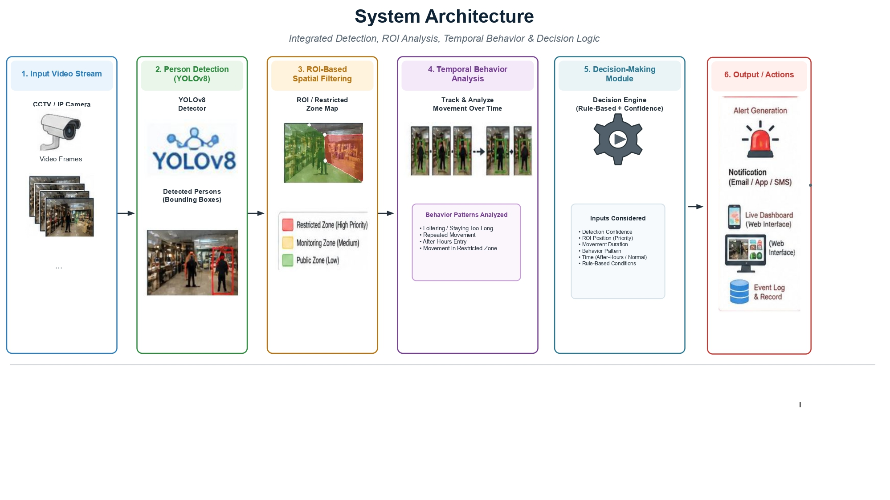

Fig 1: System Architecture

7.1 Research / Model / Experimental Design
This research is following an experimental and prototype-based design that combines deep learning-based person detection, ROI-based restricted zone analysis, temporal behavior observation, and a rule-based decision-making module to develop a real-time surveillance system for detecting possible intrusion and suspicious activities in environments.
This proposed system works as one complete surveillance pipeline. First, YOLOv8 detects people from the video frames. Then, the ROI logic checks whether the detected person has entered any restricted or sensitive area. After that, the system observes the person’s movement for a short period to understand whether the activity looks suspicious or normal. And the decision logic then generates alerts based on confidence, location, and behavior.
Methodology Steps in Detail
7.1.1 Literature Review
We have reviewed recent studies from the last 2-3 years related to deep learning studies on video surveillance, intrusion/suspicious activity detection, ROI-based monitoring, and edge-based computer vision systems.
The review will focus on key issues, such as high false alarm rates, limited awareness of the surroundings, poor performance in low light, and the challenge of running large deep learning models on smaller, lightweight devices.
7.1.2 Problem Definition
The main difficulty is how to develop a real time surveillance system that can detect intrusion and suspicious behaviors with better accuracy than motion detection or standard CCTV.
Normal activity can readily elicit false positives, as much surveillance equipment still relies on manual observation or simple alerting. They also forgot to concentrate on the most crucial locations such as restricted areas, cash counters and entrances.
This study seeks to investigate the impact of decision logic, ROI-based regional filtering, time-based behavior analysis, and YOLOv8 on the accuracy of intrusion detection and false alarm reduction.
7.1.3 Data Collection and Preprocessing
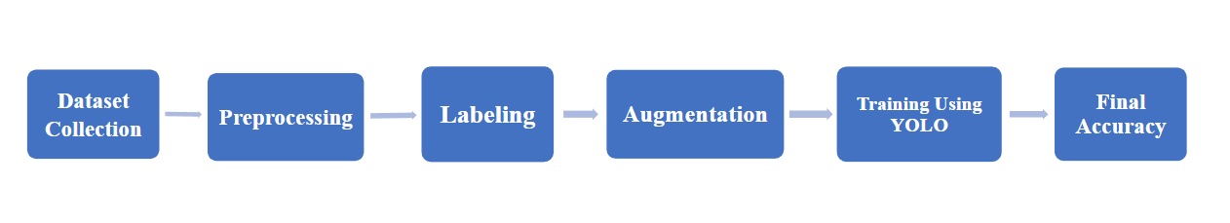

Fig 2: Data Collection and Preprocessing

Table 1: Data Sources
Dataset | Purpose
UCF-Crime Dataset | Burglary, Robbery, Fighting and other abnormal activities
ShanghaiTech Campus Dataset | Anomaly and Unusual Behaviour Detection
UCSD Pedestrian Dataset | Loitering and abnormal pedestrian movement

Table 2: Preprocessing Steps:
Step | Description
Data Cleaning | Remove blurred, overexposed, duplicate or unclear frames
Annotation | Label persons and suspicious activities using RoboFlow
ROI Marking | Define restricted zones such as cash counter or private area
Data Augmentation | Apply brightness adjustment, noise injection, low light enhancement and motion blur
Normalization | Resize images and normalize pixel values
Data Splitting | Divide data into training (75%), validation (15%) and testing (10%) sets

7.1.4 Model/ Methodology Development
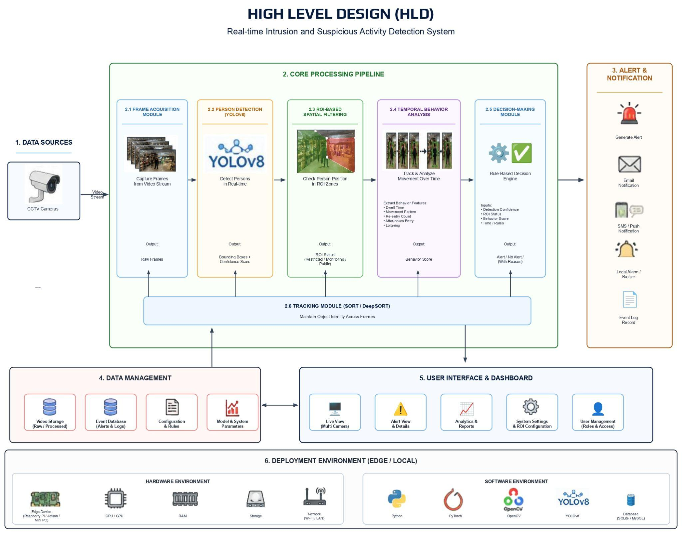

Fig 3: High Level Design(HLD)
7.1.5 Experimental Setup and Evaluation
Experimental Setup :
We will be using Python, YOLOv8, OpenCV and Pytorch in Google Colab. The system will identify people, check ROI, track movement patterns and generate alerts based on frame-by-frame video data.

Table 3: Evaluation
Metric | Purpose
Accuracy | Measures overall correct detection
Precision | Measures how many detected alerts are actually correct
Recall | Measures how many real suspicious activities are detected
F1-score | Balances precision and recall
False Alarm Rate | Measures how many wrong alerts are produced
Processing Speed | Measures FPS and real time performance
Latency | Measures alert generation delay
We will compare ROI-based decision systems to a baseline detection-only system. This will demonstrate if ROI logic and decision rules minimize false alarms and increase performance.
7.1.6 System/ Prototype Integration :
A prototype surveillance system will be created to enable real-time monitoring. The system will accept the footage input from a CCTV or webcam locally and produce an alert when it identifies suspicious behavior.

Table 4: System Integration
Component | Function
Video Input Module | Take CCTV video stream
YOLOv8 Detection Module | Detect person in real time
ROI Module | Checks restricted zone entry
Temporal Observation Module | Observes movement over time
Decision Logic Module | Decides whether an activity is suspicious
Alert Module | Sends notification
Dashboard | Shows live monitoring results

The system will be tuned for good performance with low latency needs for lightweight, resource limited devices

7.1.7 User Testing and Validation
The monitoring dashboard and alarm system will be evaluated using sample users like store owners, security workers or general users.
The testing will focus on the ability of the system to detect suspicious behaviors, not to have superfluous alerts and to deliver clear warning information. User comments will be collected to enhance the design of the dashboard, alert messages and overall usability of the system.

7.1.8 Analysis and Interpretation of Results
The system performance will be evaluated in diverse circumstances including regular mobility, restricted zone access, poor light conditions, loitering and after hour intrusion.

Table 5: Alert Decision Logic
Alert Reason | Example
Restricted Zone entry | Person entered restricted zone
Long Stay duration | Person stayed near restricted zone for too long
After hours Movement | Person detected after shop closing time
Low confidence alert ignored | Detection confidence was below threshold
The findings will be reported in terms of accuracy, precision, recall, F1-score , false alarm rate and preprocessing speed. Confusion matrices will be used to identify false positives and false negatives.

8. Project Timeline (Gantt Chart)

Table 6: Project Timeline (Gantt Chart)
SL | Phase | Duration(Days) | Start Date | End Date | Dependencies
1 | Literature Review, Research Gaps | 30 | 01-12-2025 | 31-12-2025 | None
2 | Research Planning | 14 | 01-01-2026 | 14-01-2026 | Literature Review and Research Gaps
3 | Data Collection and Preprocessing | 21 | 15-01-2026 | 04-02-2026 | Research Planning
4 | Annotation | 14 | 05-02-2026 | 18-02-2026 | Data Collection and Preprocessing
5 | YOLOv8 Implementation and ROI Logic | 28 | 19-02-2026 | 18-03-2026 | Annotation
6 | Temporal Modelling | 21 | 19-03-2026 | 08-04-2026 | YOLOv8 Implementation and ROI Logic
7 | Decision Fusion Integration | 21 | 09-04-2026 | 29-04-2026 | Temporal Modelling
8 | Evaluation and Testing | 28 | 30-04-2026 | 27-05-2026 | Decision Fusion Integration
9 | Report, Documentation and Defense | 28 | 28-05-2026 | 24-06-2026 | Evaluation and Testing

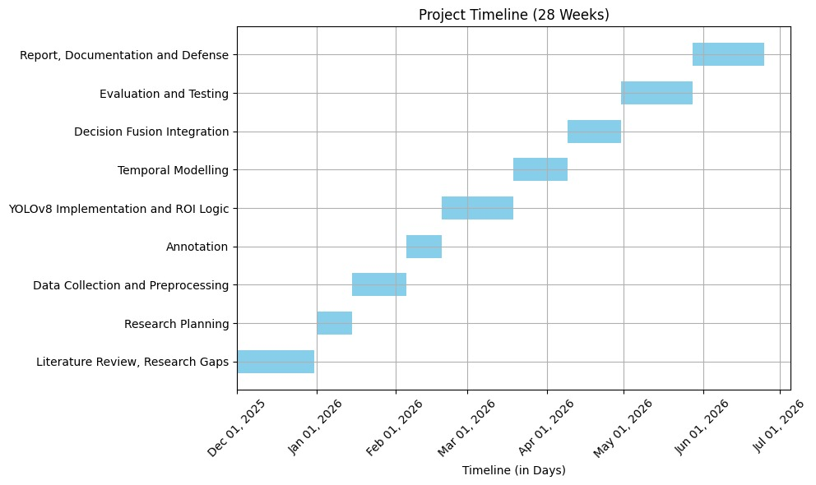

Fig 4: Project Timeline(Gantt Chart)

9. Modern Tools & Technologies

Table 5: Modern Tools & Technology
Category | Tools/Technologies | Description
Programming &  Development | Python(3.9 or higher) | Primary programming language used for implementing the system, enabling flexibility for machine learning and computer vision tasks.
 | PyTorch | Deep learning framework used for training models, including YOLOv8 for real-time detection and temporal behavior analysis.
 | Git/Github | Git for version control and GitHub for code collaboration, repository management, and team coordination.
Computer Vision &  Image Processing | OpenCv | OpenCV handles video frame processing and extraction, essential for real-time monitoring and frame manipulation.
 | YOLOv8 | YOLOv8 is used for high-speed object detection and tracking persons across video frames in real time.
Evaluation &  Merits | Robolflow | Data annotation tool for labeling video frames to identify behaviors and activities of interest.
 | Scikit-learn | Evaluation library used for calculating performance metrics such as accuracy,precision,recall, and F1-score for model assessment.
 | Matplotlib | Visualization tool used for implementing the system, enabling flexibility for machine learning and computer vision tasks.

10. Ethical Issues

10.1 Important Ethical Issues
Informed Consent : Clear consent will be given for any custom simulated data with human participants to attain the aim of transparency. Data from public datasets (e.g., UCF-Crime, ShanghaiTech) will be utilized exclusively under the appropriate academic licenses and in compliance with the privacy and data usage regulations.
Data Security : Video frames and datasets will be saved in secured and access controlled systems. The edge deployment strategy of the technology offers the added security of local frame processing on devices and reduces the risk of sending raw video to a centralized cloud.
Fairness & Equity : We will train the model in diverse datasets with varying lighting, clothes and body types to avoid AI producing discriminating demographic profiles. We will also do assessments to evaluate the model on under-represent groups, for fairness.
Transparency & Explainability : The Decision Fusion Module is trained to give Explainable AI (XAI) to allow the security team to understand the full logic of the notified occurrences. This provides openness in decision making and gives clear and comprehensible results for users for users which builds trust in the system.
Privacy & Data Protection : All collected data sets will include masked faces, and event logs will employ anonymous tracking IDs instead than retaining raw facial photos. This prevents the storage of personally identifying data. Requests to opt out will be honoured and privacy rights will be dealt with according to data protection standards and regulations, such as General Data Protection Regulation (GDPR) or local legislation.
Accountability : To guard against such biases, the study team will monitor the system’s efficiency and assessment measures. We suggest a “human-in-the-loop” approach for the final choice on generating an alarm, avoiding full dependence on automated operations and improving the accuracy and trustworthiness of the system.

10.2 Demonstration of Ethical Awareness
The application of machine learning in surveillance systems creates significant ethical difficulties such as invasion of privacy,biased algorithms and abuse of sensitive tracking data. “We have to take a close look at predictive security systems to avoid demographic profiling, false acquisitions and privacy breaches.” This article tackles these concerns with a responsible AI deployment for fairness, transparency and privacy protection. The system design encourages social responsibility through participants, informed permission, and reduction of algorithmic bias, which contributes to trust and acceptance.

10.3 Commitment of Responsible Research Practices
We are dedicated to responsible, ethical research.This is evidenced by our focus on:
Data Security :– All datasets and video frames will be securely saved utilizing robust encryption methods.
Transparency The Decision logic of the XAI model is transparent and understandable.
Anonymization :– All video frames being captured will have any personally identifiable data anonymised to prevent any privacy violations.
Bias Mitigation :– We are committed to reducing model bias by using different data sources and fairness testing to maintain the egalitarian character of our system.
This project intends to build a privacy-preserving, socially responsible system compliant with contemporary requirements of data protection.

11. Budget Estimation

Table 6: Budget Estimation
SL. | Category | Item/ Components | Purpose | Cost (BDT)
 | Software and Development | Python,OpenCV,PyTorch, YOLOv8, Scikit-learn, GitHub,Google Colab | Model development, training, evaluation, version control | 0
 | Dataset and Annotation | Dataset download (e.g., UCF-Crime, ShangaiTech), Roboflow, Manual Annotation | Dataset preparation, annotation, preprocessing | 2000-8000
 | Hardware for Testing | Webcam/IP Camera, Tripod, Cables, SSD/External Storage | Video input, camera setup, and data storage | 9000-22,000
 | Network and Backup | Router/Network support, UPS for power backup | Ensure stable connection and prevent interruptions during tests | 6,500-13,000
 | Field Testing Setup | Transport for field testing, shop/home setup, custom video recording | Real-world testing and capturing intrusion scenarios | 8,000-20,000
 | Documentation and Presentation | Report Printing, binding, poster, and presentation materials | Final thesis/report submission and defense presentation | 4,000-9,000
 | Backup / Contingency | Unforeseen costs or issues during research | Cover unexpected expenses | 5,000-10,000

12. Conclusion
In this study we offer a novel lightweight computer vision system that combines real-time human tracking, trigger-based posture estimation and night picture augmentation.These innovations fill key hopes in the retail monitoring systems of today.
The system employs a time-aware behavioral scoring method, instead of the traditional binary warnings, to make strong, explainable security choices with a large reduction in false positives. The system’s decision fusion module offers clear and actionable insights that fosters user trust.
The study provides a major contribution to intelligent surveillance by bridging the gap between theory of intrusion detection and its practical implementation.Robust data security, privacy protection and transparency procedures assure ethical usage of AI, making this solution suited for both retail and home security applications.

References
- Sodhro, A. H., Kannam, S., & Jensen, M. (2025). Real-time efficiency of YOLOv5 and YOLOv8 in human intrusion detection across diverse environments and recommendation. Internet of Things, 33, 101707.
https://doi.org/10.1016/j.iot.2025.101707
- Priyanka, H., Ankitha, A. C., Rao, P. S., Modi, U., & Naik, C. (2025). Anomaly detection in surveillance videos. In Proceedings of the 20th International Conference on Evaluation of Novel Approaches to Software Engineering (ENASE 2025) (pp. 676-683).
https://doi.org/10.5220/0013426200003928
- Yang, Z., Gao, C., Liu, J., Wu, P., Pang G., & Shou, M. Z. (2025). AssistPDA: An online video surveillance assistant for video anomaly prediction, detection, and analysis. arXiv preprint arXiv: 2503.21904.
https://arxiv.org/abs/2503.21904
- Rashvand, N., Alinehad Noghre, G., Danesh Pazho, A., Rahumi Ardabili, B., & Tabkhi, H. (2025). Shopformer: Transformer-based framework for detecting shoplifting via human pose. arXiv preprint arXiv: 2504.19970.
https://arxiv.org/abs/2504.19970
- Lee, H., Kim, H., Kim, I.-J, & Choi, Y. (2025). PrismVAU: Prompt-refined inference system for multimodal video anomaly understanding. arXiv preprint arXiv:2505.15205.
https://arxiv.org/abs2505.15205
- Erregue, I., Nasrollahi, K, & Escalera, S. (2026). PrismVAU: Prompt-refined inference system for multimodal video anomaly understanding. arXiv preprint arXiv:2601.02927.
https://arxiv.og/abs/2601.02927
- Lyu, J., Zhao, M., Huang, X., Chen, Y., Du, S., Hu, J., Shi, C., & Lv, Z. (2026). Forward consistency learning with gated context aggregation for video anomaly detection. arXiv preprint arXiv:2601.18135.
https://arxiv.org/abs/2601.18135
- Liu, Z., Wu, X., Li, W., Wu, J., & Yang, L. (2026) ESOM: Efficiently understanding streaming video anomalies with open-world dynamic definitions. arXiv preprint arXiv:2604.07772.
https://arxiv.org/abs/2604.07772
- Monica, V., & Saranya, N. (2026). AI-based military intrusion detection system using YOLOv8. International Journal of Sciences and Innovation Engineering. 3(3), 396-400.
https://doi.org/10.70849/ijsci03032600479
- Cao, C., Lu, Y., Wang, P., & Zhang, Y. (2023). A new comprehensive benchmark for semi-supervised video anomaly detection and anticipation. In Proceedings of the IEEE/CVF Conference on Computer Vision and Pattern Recognition (CVPR) (pp. 20392-20401).
https://doi.org/10.1109/CVPR52729.2023.01953
- Baradaran, M. & Bergevin, R. (2023). Multi-task learning based video anomaly detection with attention. In Proceedings of the IEEE/CVF Conference on Computer Vision and Pattern Recognition Workshops (CVPRW) (pp. 2886-2896).
https://doi.org/10.1109/CVPRW59228.2023.00290
- Chen, J., Li, L., Su, L., Zha, Z.-J., & Huang, Q. (2024). Prompt-enhanced multiple instance learning for weakly supervised video anomaly detection. In Proceedings of the IEEE/CVF Conference on Computer Vision and Pattern Recognition (CVPR) (pp. 18319-18329).
https://doi.org/10.1109/CVPR52733.2024.01734
- Cho, M. A.,Kim, M., Hwang, S., Park, C., Lee, K., & Lee, S. (2023). Look around for anomalies: Weakly-supervised anomaly detection via context-motion relational learning. In Proceedings of the IEEE.CVF Conference on Computer Vision and Pattern Recognition (CVPR) (pp. 12137-12146).
https://doi.org/10.1109/CVPR52729.2023.01168
- Dalvi, J., Dabouei, A., Dhanuka, G., & Xu, M. (2025). Distilling aggregated knowledge for weakly-supervised video anomaly detection. In Proceedings of the IEEE/CVF Winter Conference on Applications of Computer Vision (WACV) (pp.5439-5448).
https://doi.org/10.1109/WACV61041.2025.00531
- Dawoud, K., Zaheer, M. Z., Khan, M., Nandakumar, K., El Saddik, A., & Khan, M. H. (2025). FusedVision: A knowledge-infusing approach for practical anomaly detection in real-world surveillance videos. In Proceedings of the IEEE/CVF Conference on Computer Vision and Pattern Recognition Workshops (CVPRW) (pp. 4045-4055).
https://doi.org/10.1109/CVPRW67362.2025/00388
- Huang, Y., Li, C., Zhang, H., Lin, Z., Lin, Y., Liu, H., Li, W., Liu, X., Gao, J., Huang, Y., Ding, X., & Yuan, Y. (2025). Track any anomalous object: A granular video anomaly detection pipeline. In Proceedings of the IEEE/CVF Conference on Computer Vision and Pattern Recognition (CVPR) (pp. 8689-8699).
https://doi.org/1048550/arXiv.2506.05175
- Rai, A. K., Krishna, T., Hu, F., Drimbarean, A., McGuinness, K., Smeation, A. F., & O’Connor, N. E. (2024). Video anomaly detection via spatio-temporal pseudo-anomaly generation: Unified approach. In Proceedings of the IEEE/CVF Conference on Computer Vision and Pattern Recognition Workshops (CVPRW) (pp. 3887-3899).
https://doi.org/10.1109/CVPRW63382.2024.00393
- Li, F., Liu, W., Chen, J., Zhang, R., Wang, Y., Zhong, X., 7 Wang, Z. (2025). Anomize: Better open vocabulary video anomaly detection. In Proceedings of the IEEE/CVF Conference on Computer Vision and Pattern Recognition (CVPR) (pp. 29203-29212).
https://doi.org/10.1109/CVPR52734.2025.02719
- Singh. A., Jones, M. J., & Learned-Miller, E.G. (2023). EVAL: Explainable video anomaly localization. In Proceedings of the IEEE/CVF Conference on Computer Vision and Pattern Recognition (CVPR) (pp. 19297-18307).
https://doi.org/10.1109/CVPR52729.2023.01795
- Wu, P., Zhou, X., Pang, G., Sun, Y., Liu, J., Wang, P., & Zhang, Y. (2024). Open-vocabulary video anomaly detection. In Proceedings of the IEEE/CVF Conference on Computer Vision and Pattern Recognition (CVPR) (pp. 18297-18307).
https://doi.org/10.1109/CVPR52733.2024.01732
- Xu, C., Li, C., & Xing, H. (2025). Discriminative score suppression for weakly supervised video anomaly detection. In Proceedings of the IEEE/CVF Winter Conference on Applications of Computer Vision (WACV) (pp. 9569-9578).
https://doi.org/10.1109/WACV61041.2025.00928
- Yang, Z., & Radke, R. J. (2024). Context-aware video anomaly detection in long-term datasets. In Proceedings of the IEEE/CVF Conference on Computer Vision and Pattern Recognition Workshops (CVPRW) (pp. 4002-4011).
https://doi.org/10.1109/CVPRW63382.2024.00404
- Yun, S., Masukawa, R., Na, M., & Imani, M. (2025). MISSION GNN: Hierarchical multimodal GNN-based weakly supervised video anomaly recognition with mission-specific knowledge graph generation. In Proceedings of the IEEE/CVF Winter Conference on Applications of Computer Vision (WACV) (pp. 4736-4745).
https://doi.org/10.1109/WACV61041.2025.00464
- Zannela, L., Menapace, W., Mancini, M., Wang, Y., & Ricci, E. (2024). Harnessing large language models for training-free video anomaly detection. In Proceedings of the IEEE.CVF Conference on Computer Vision and Pattern Recognition (CVPR) (pp. 18527-18536).
https://doi.org/10.1109/CVPR52733.2024.01753
- Zhang, M., Wang, J., Qi, Q., Sun, H., Zhuang, Z., Ren, P., Ma, R, & Liao, J. (2024). Multi-scale video anomaly detection by multi-grained spatio-temporal representational learning. In Proceedings of the IEEE/CVF Conference on Computer Vision and Pattern Recognition (CVPR) (pp. 17385-17394).
https://doi.org/10.1109/CVPR52733.2024.01646
- Gawande, U., Hajari, K., & Golhar, Y. (2024). Novel person detection and suspicious activity recognition using enhanced YOLOv5 and motion feature map. Artificial Intelligence Review, 57, Article 16.
https://doi.org/10.1007/s10462-023-10630-0
- Saleem, L. A., & Jerith, G. G. (2026). A deep learning driven framework with ObjTrackNet for real-time object and human detection in smart video surveillance.Discover Computing, 29, Article 238.
https://doi.org/10.1007/s10791-026-10143-8
- Zhang, P., & Lu, Y. (2023). Research on anomaly detection of surveillance video based on Branch-Fusion Net and CSAM. Sensors, 23(3), 1385.
https://doi.org/10.3390/s23031385
- Zhang, Y., Song, J., Jiang, y., & Li, H. (2023). Online video anomaly detection. Sensors, 23(17), 7442.
https://doi.org/10.3390/s23177442
- Abu Awwad, Y., Rana, O., & Perera, C. (2024). Anomaly detection on the edge using smart cameras under low-light conditions. Sensors, 24(3), 772.
https://doi.org/10.3390/s2403077

Plagiarism & AI-Detect Report:

AI-Detect Report:


Plagiarism Checking Report:


